New California budget data shows staggering $1.8 billion deficit in our program funding, which is causing a workforce crisis that now jeopardizes the health, safety and well-being of people with developmental disabilities. It’s time for the legislature to take a step on the #PathForward #WhatsMyWorth

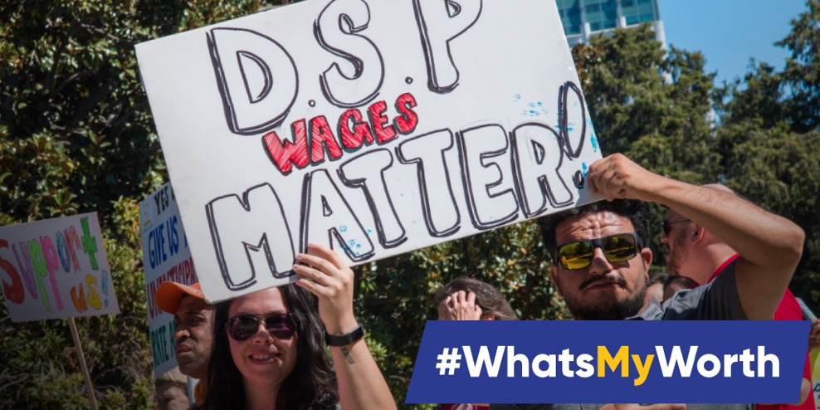

The State’s own data is staggering. It shows how California has chronically underfunded community-based services by 40% and left an unprecedented $1.8 Billion shortfall in necessary funding for people with developmental disabilities. Work with us on the #PathForward #WhatsMyWorth

The #PathForward Collaborative is ready to act! California must professionalize the disability services workforce and provide the competitive wages necessary to recruit, train and retain critical support staff. Time to take a step on the #PathForward #WhatsMyWorth

