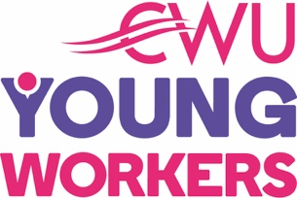
CWU Young Workers
National Young Workers’ Education Event 2018
12 October – 14 October, The Bull Hotel, Peterborough

APPLICATION TO ATTEND

Name ......................................................................................................................

CWU Branch ............................................................................................................

Employer.............................................................................................................

Address for Correspondence ...................................................................................
(Please ensure you supply your full address including Postcode)
................................................................................................................................

...............................................................................................................................

Telephone Number ................................................................
(Important so that a CWU Young Workers Committee member can make contact prior to the event)

Email .....................................................................................
(Important so that we can send notifications at short notice prior to the event)

Date of Birth ..........................................................................

Is this your first time? Yes/No

If No how many times have you attended the NYEE?

Special Needs Requirements (please state)

................................................................................................

Dietary Requirements (e.g. vegetarian)

................................................................................................

Will you need the use of a Crèche?*** Yes/No

Will you require a prayer room? Yes/No

Signature ................................................................................

Branch Secretary Signature .....................................................

Branch ......................................................................................

Date …………………………………………………………………………………

Please return to Jo Thair, at CWU Head Office via post or email: jthair@cwu.org

