MHAROC Peer Academy Registration
Name (First and Last): Agency and Role/Position [If Applicable]:
________________________________________________________________________________________
Phone: E-mail:
________________________________________________________________________________________
Address:
________________________________________________________________________________
Emergency Contact - Name (First and Last): Phone:
________________________________________________________________________________

Are you attending the Peer Academy to work toward becoming a New York Certified Peer Specialist (NYCPS)?
 | Yes, full certification |  | Yes, provisional certification |  | No/I’m not sure

 | Yes |  | No

Have you ever used the Academy of Peer Services website before?
If yes, do you remember which courses you took, and/or how many you completed?
__________________________________________________________________________________________
 | Yes |  | No

Have you worked or volunteered as a peer support specialist?
If yes, please describe this experience briefly
____________________________________________________________________________________________________________________________________________________________________________________

At the Peer Academy, I am interested in… [Check all that apply]:
 | Learning new peer support skills |  | Technical help with Academy of Peer Services |  | Assistance with completing NYCPS application
 | Support to prepare for certification |  | A community to discuss peer support work |  | Finding peer support volunteer and work opportunities

Is there anything else you are hoping to get from your experience with the Peer Academy?

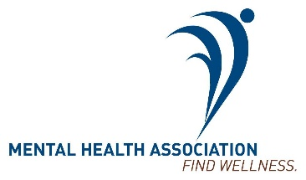
______________________________________________________________________________________________________________________________________________________________________________________________________________________________________________________________________________

Please send your completed registration via e-mail to Kirsten at kmuckstadt@mharochester.org, or send/bring your completed registration to
MHA Life Skills Services at 344 N. Goodman St. Rochester, NY 14607.
Please call (585) 224-2005 with any questions.

